Straw Towers

Subject: Physics, Math  Related Subjects: Civil Engineering | Grade Level(s): 4-8  Length of Lesson: 45 minutes | Type: Project  Keywords: Structure, Stability, Geometry, Engineering, Design, Triangles

Lesson Overview
Students will explore geometric principles of structural design by building towers out of straws and tape. Through this challenge, students discover the importance of triangles in engineering and how repeated shapes and strong bases contribute to structural stability.

Lesson Focus
What shapes make a structure stable and strong? Why are triangles used so often in bridges and buildings?

Lesson Objective(s) | - Understand how geometric shapes influence structural strength.  - Identify the triangle as the most stable shape in construction.  - Apply engineering skills to design and build a tall, freestanding tower.

Lesson Timing

5 minutes | Introduce the Lesson
30 minutes | Tower construction activity
10 minutes | Presentations and height measurement
5 minutes | Wrap-up and reflection

Materials | - 1 Box of straws  - 1 Roll of tape  - 10 Rulers  - 80 Card stock sheets
Instructor Prep | - Prepare tape in 12” segments (one per team).  - Ensure each group has a base (cardstock) and access to straws.  - Set a clear workspace with measurement tools ready for judging.  - Consider building a sample triangle-based structure for visual reference.
Related Resources | - Straw Tower Challenge  - Straw Towers to the Moon - Activity - TeachEngineering

Lesson Plan

Introduction

The power of the triangle!

Questions to ask:
- What do you think the strongest shape is?
Triangles are the strongest shape, and they can be seen in many bridges and buildings. There are a few reasons triangles are so strong.
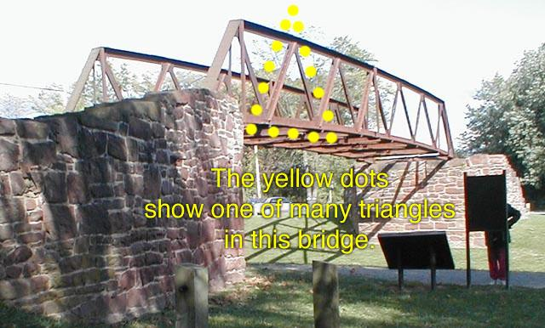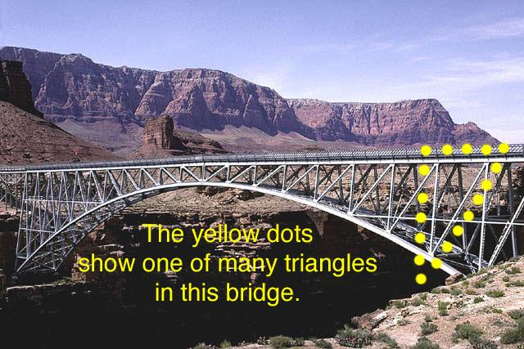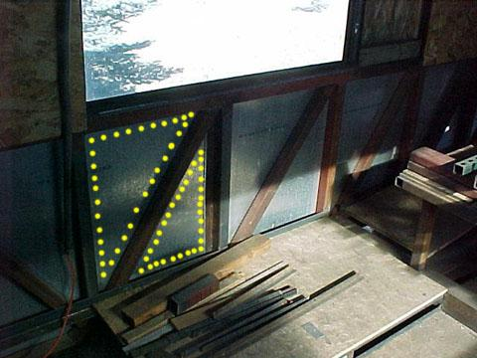
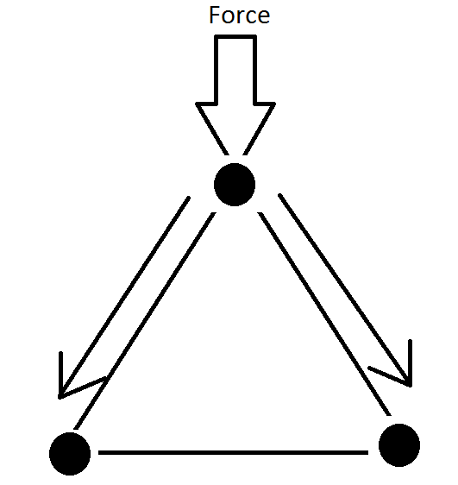
Reasons triangles are the strongest:
- When a force is placed on a triangle it is evenly distributed to the other points of the shape.
- The size of a triangles base is also larger than its top, thus it is more stable because its weight is strongly supported at the bottom.
- Triangles are inherently strong because they form a fixed rigid shape

Patterns
When you see a building what do you notice? Buildings have recurring patterns. This is important to note, because if they were randomly designed it would be harder for them to stand up. This pattern makes them stronger because it reinforces their design. Repeating a strong pattern makes a strong building.


Procedure
- Distribute materials to each group: 1 cardstock sheet, a 12” piece of tape, and access to straws.
- Explain the rules:
- The tower must be attached to the cardstock base.
- The tower must stand on its own.
- You can only use the given tape and cardstock—no extra materials.
- You have 30 minutes to build the tallest structure possible.
- Encourage students to explore different shapes—ask what happens when they use triangles vs. squares.
- Once time is up, measure the height of each tower from the base to the highest point.
- Discuss why some towers stood better than others—highlight the use of triangle patterns and base stability.

Wrap-up
What made the strongest towers stand tall? What would you do differently next time? Highlight how repeating strong shapes like triangles adds strength to buildings and how engineers apply these same concepts in real life.

Lesson Background for Teachers
Triangles are the most stable shape in engineering because they distribute force evenly and retain their shape when pressure is applied. Repetition of triangles in trusses and frameworks reinforces structures. This activity introduces basic structural engineering concepts and allows students to explore through trial and error.

Suggested Real-World STEM Connections
- Civil Engineers who design buildings, bridges, and towers
- Architects who plan safe and strong structures using geometry
- Construction Engineers who implement designs in real-world builds

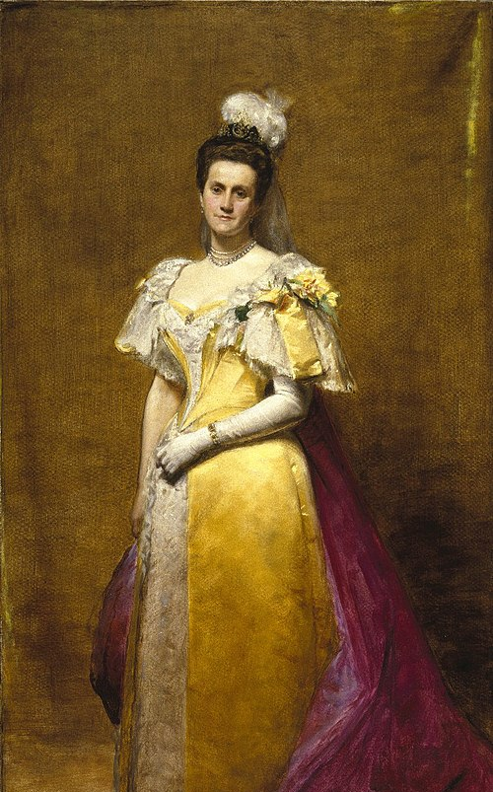
Emily Warren Roebling
Emily Warren Roebling (September 23, 1843 – February 28, 1903) was an engineer known for her contributions over a period of more than 10 years to the completion of the Brooklyn Bridge after her husband Washington Roebling developed caisson disease (a.k.a. decompression disease) and became bedridden. She served as a liaison and supervisor of construction through communicating between her husband and on-site personnel. Her husband was the chief engineer during construction of the Brooklyn Bridge, which had been designed by his late father, John A. Roebling.
The Brooklyn Bridge was completed in 1883. In advance of the official opening, carrying a rooster as a sign of victory, Emily Roebling was the first to cross the bridge by carriage. At the opening ceremony, Roebling was honored in a speech by Abram Stevens Hewitt, who said that the bridge was an everlasting monument to the sacrificing devotion of a woman and of her capacity for that higher education from which she has been too long disbarred.

Lesson Variations and Options
- Add constraints such as limited time or maximum number of straws
- Test tower stability by gently blowing or shaking the table
- Combine this with a bridge-building or earthquake-resistance challenge

Explanation
Triangles are inherently stable because their angles are fixed when connected. Squares and rectangles can shift unless supported. By repeating triangles, engineers reinforce the strength of their designs and distribute weight and forces more evenly across a structure.

Key Concepts and Vocabulary
- Triangle: A strong geometric shape used in construction for stability
- Structure: Something built or constructed
- Stability: The ability of a structure to remain upright and firm
- Force: A push or pull that can change motion or shape

Safety Notes
- Avoid poking others with straws
- Clean up stray tape and straw pieces at the end of the activity

